**CYPRUS INTERNATIONAL UNIVERSITS**

**Circuit Theory**

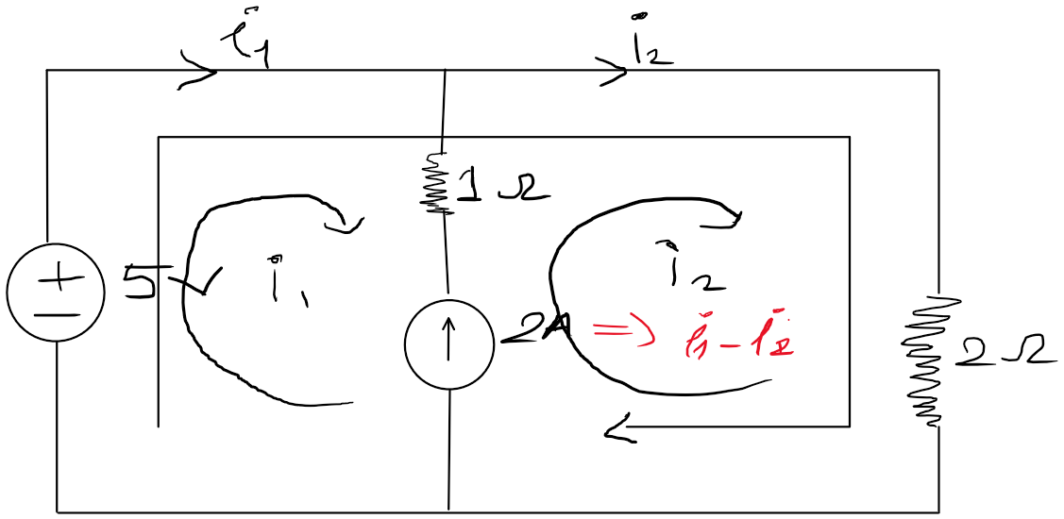

Using mesh analysis , find mesh currents İ1 & İ2

Apply KVL in loop – 1

5 – 2İ2 = 0 => İ2=5/2 =2.5A

Now İ1-İ2 = -2A => İ1 -2.5 =-2 => İ1 = 0.5 A

İ1 =0.5 A İ2 = 2.5 A